Recursion

What Is Recursion?
The word recursion comes from the Latin word “recurrere”, meaning to run or hasten back, return, revert, or recur
A recursive definition is one in which the defined term appears in the definition itself.
Self-referential situations often crop up in real life, even if they aren’t immediately recognizable as such.
For example, suppose you wanted to describe the set of people that make up your ancestors. You could describe them this way:
Notice how the concept that is being defined, ancestors, shows up in its own definition. This is a recursive definition.


In programming, recursion has a very precise meaning.
It refers to a coding technique in which a function calls itself.

If you’re familiar with functions in Python, then you know that it’s quite common for one function to call another. In Python, it’s also possible for a function to call itself!
A function that calls itself is said to be recursive, and the technique of employing a recursive function is called recursion.

For better understanding of recursion remember the pizza place analogy.

Why Use Recursion?
Most programming problems are solvable without recursion. So, strictly speaking, recursion usually isn’t necessary.
However, some situations particularly lend themselves to a self-referential definition—for example, the definition of ancestors shown above. If you were devising an algorithm to handle such a case in programming, a recursive solution would likely be cleaner and more concise.
Using recursive algorithm, certain problems can be solved quite easily. Examples of such problems are Towers of Hanoi (TOH), Inorder/Preorder/Postorder Tree Traversals etc.
On the other hand, recursion isn’t for every situation. Here are some other factors to consider:
- For some problems, a recursive solution, though possible, will be awkward rather than elegant.
- Recursive implementations often consume more memory than non-recursive ones.
- In some cases, using recursion may result in slower execution time.
Typically, the readability of the code will be the biggest determining factor.

Recursion in Python

When you call a function in Python, the interpreter creates a new local namespace so that names defined within that function don’t collide with identical names defined elsewhere.

One function can call another, and even if they both define objects with the same name, it all works out fine because those objects exist in separate namespaces.
The same holds true if multiple instances of the same function are running concurrently. For example, consider the following definition:
def function():
x = 10
function()

When function() executes the first time, Python creates a namespace and assigns x the value 10 in that namespace. Then function() calls itself recursively. The second time function() runs, the interpreter creates a second namespace and assigns 10 to x there as well.
These two instances of the name x are distinct from each another and can coexist without clashing because they are in separate namespaces.
Unfortunately, running function() raises an Error, as you can see below:
>>> function()
Recursion Error: maximum recursion depth exceeded

As written, function()would in theory go on forever, calling itself over and over without any of the calls ever returning. In practice, of course, nothing is truly forever. Your computer only has so much memory, and it would run out eventually.
Python doesn’t allow that to happen. The interpreter limits the maximum number of times a function can call itself recursively, and when it reaches that limit, it raises a Recursion Error.
Open recursion_limit.py file

Stopping Case
There isn’t much use for a function to indiscriminately call itself recursively without end. It’s reminiscent of the instructions that you sometimes find on shampoo bottles: “Lather, rinse, repeat.” If you were to follow these instructions literally, you’d shampoo your hair forever! You need to know when to stop.
Similarly, a function that calls itself recursively must have a plan to eventually stop.
Recursive functions typically follow this pattern:
- There are one or more base cases that are directly solvable without the need for further recursion.
- Each recursive call moves the solution progressively closer to a base case.

Examples
1 → Open countdown.py file
2 → Calculate Factorial
You can express the definition of n! recursively like this:
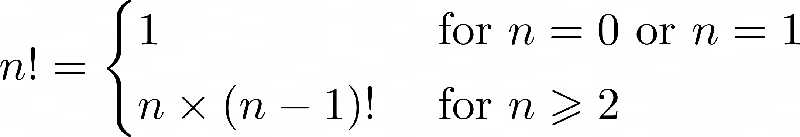
As with the example shown above, there are base cases that are solvable without recursion.
The more complicated cases are reductive, meaning that they reduce to one of the base cases:
- The base cases (n = 0 or n = 1) are solvable without recursion.
- For values of n greater than 1, n! is defined in terms of (n - 1)!, so the recursive solution progressively approaches the base case.

For example, recursive computation of 4! looks like this:
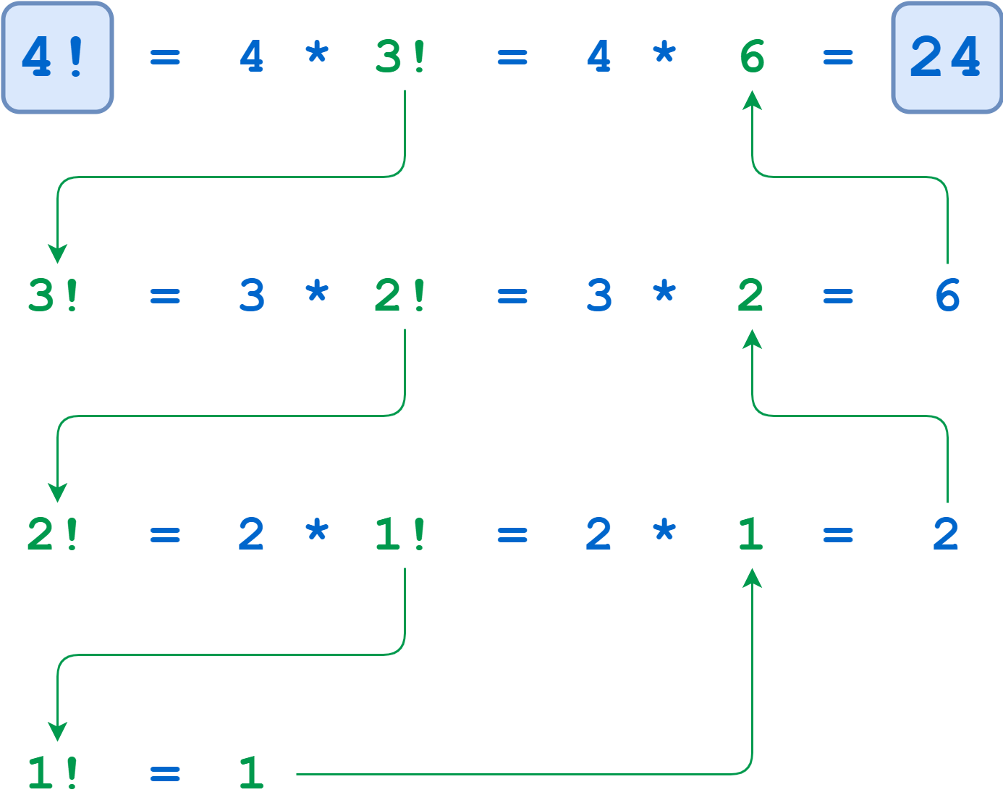
Open factorial.py file

Exercises
1) Based on the code below, by supposing the x=5 find the output of the program. Show the flow of the recursion calls and the return values of the each call.
def fun1(x, y) :

if (x == 0) :
return y
else :
return fun1(x - 1, x + y)

2) Find the sum of the digits of a number using recursion.
Solution → sum_of_digits.py

3) Find the power of a number using recursion.
Solution → power.py

4) Find the maximum number in a list using recursion
Solution → max_number.py

5) Find if a number is a Prime number or not using recursion.
A prime number is a natural number greater than 1, which is only divisible by 1 and itself
Solution → prime_number.py

6) Reverse a string using recursion.
Solution → reverse_string.py

7*) Traverse a Nested List.
Count the number of leaf elements in this list—the lowest-level str objects—as though you’d flattened out the list.
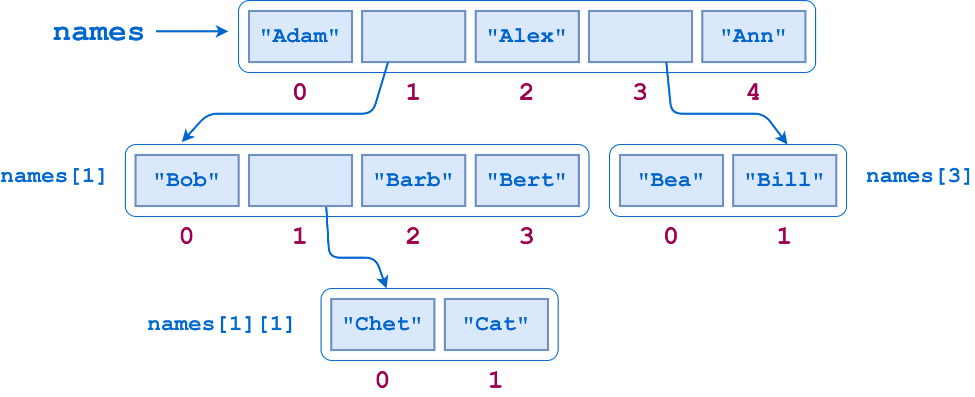
What you need here is a function that traverses the entire list structure, sublists included. The algorithm goes something like this:
- Walk through the list, examining each item in turn.
- If you find a leaf element, then add it to the accumulated count.
- If you encounter a sublist, then do the following:
  - Drop down into that sublist and similarly walk through it.
  - Once you’ve exhausted the sublist, go back up, add the elements from the sublist to the accumulated count, and resume the walk through the parent list where you left off.
TIP: To solve it, you need to be able to determine whether a given list item is leaf item or not. For that, you can use the built-in Python function isinstance().

Solution → traverse_nested_lists.py
Extra:
Dynamic Programming
The biggest problem with recursive algorithms is their resource consumption. Can this be prevented? A number of improvements have been proposed, and the algorithms implementing them are classified as dynamic programming.
The dynamic approach assumes to:
- create a recursive solution,
- create a structure for remembering solutions corresponding to the final values,
- support of the above structure in the operation of the algorithm - the solution for specific output data after the algorithm is executed is saved in the structure and is ready for later return without the need of counting.

Check → factorial_dynamic.py

